Lesson 5-3: if-then Statements

Exercise 1:

// Program Shell2 prints appropriate messages based on a
// pressure reading input from the keyboard.

#include <iostream>
using namespace std;

int main ()
{
int pressure;

cout << "Enter an integer pressure reading. "
<< " Press Return." << endl;
cin >> pressure;

if(pressure > 100)
{
cout << "Warning!! Pressure reading above danger limit."
<< endl;

}

system("pause");
return 0;
}

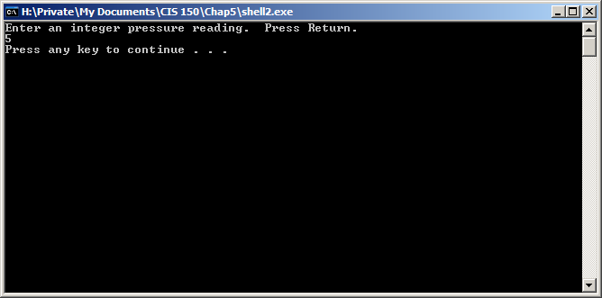
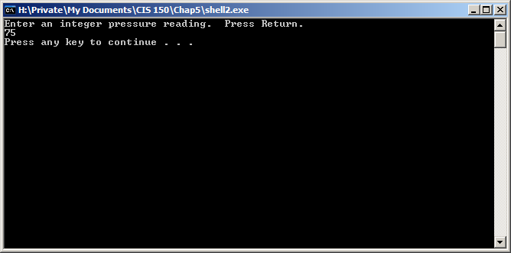
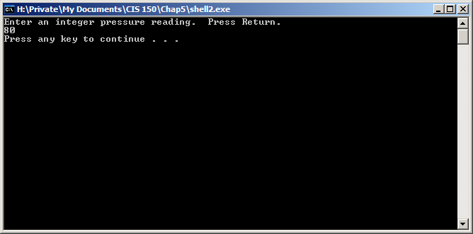
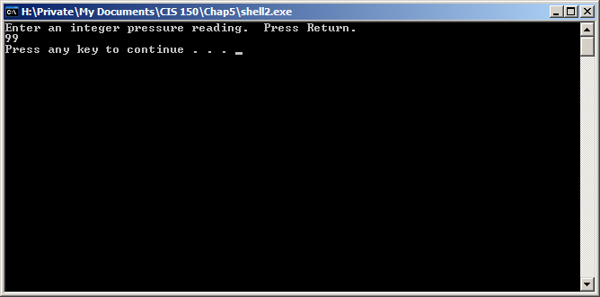
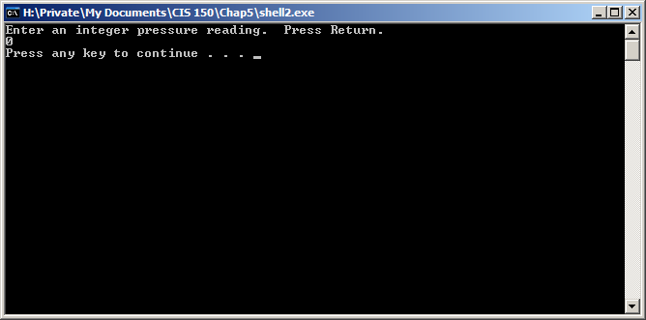
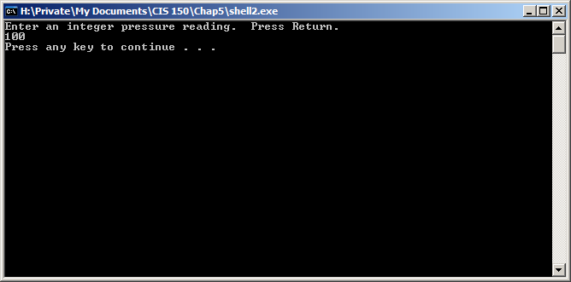
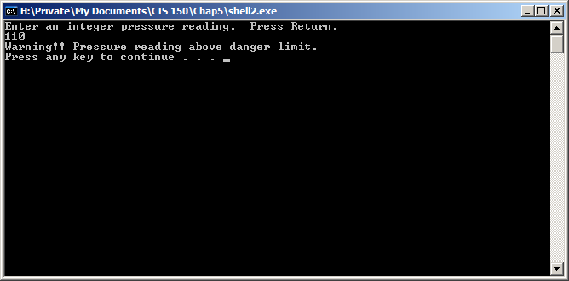
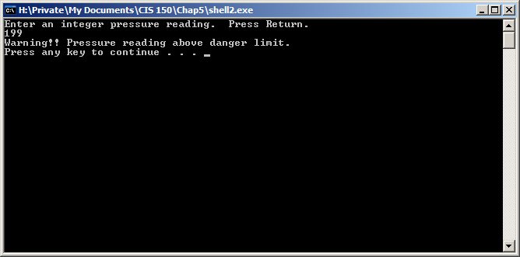

“Warning !! Pressure reading above danger limit.” is printed 2 times.

Exercise 2:

// Program Shell2 prints appropriate messages based on a
// pressure reading input from the keyboard.

#include <iostream>
using namespace std;

int main ()
{
int pressure;

cout << "Enter an integer pressure reading. "
<< " Press Return." << endl;
cin >> pressure;

if( pressure > 5 && pressure <100)
{
cout << "Everything seems normal. \n";

}

system("pause");
return 0;
}
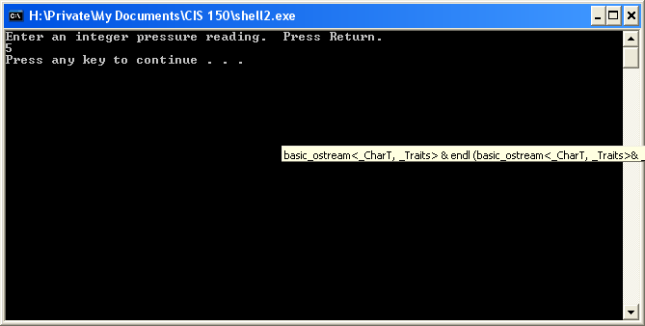
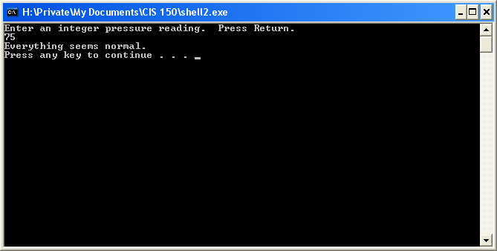
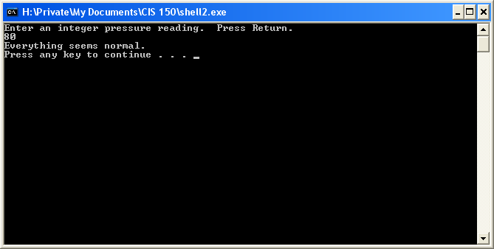
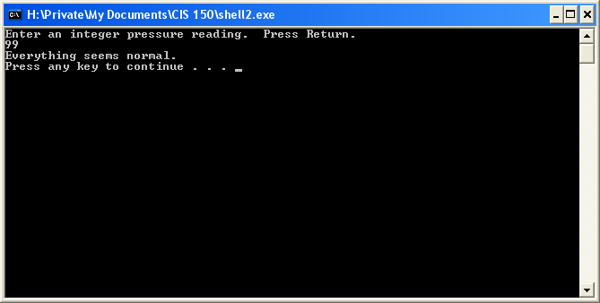
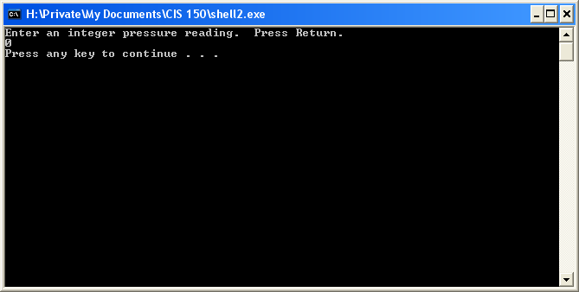
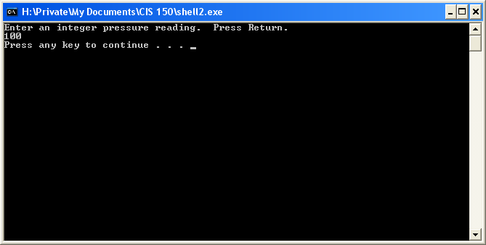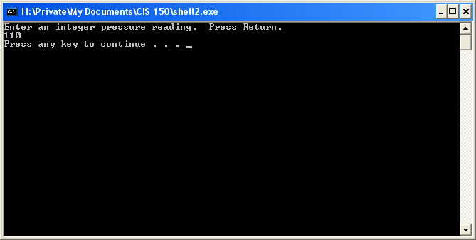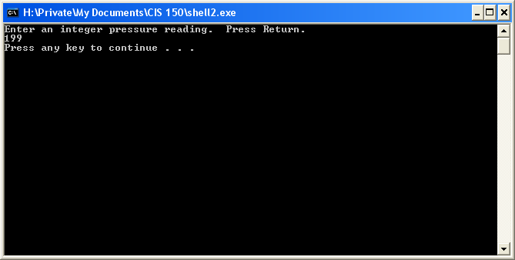

“Everything seems normal” is printed 3 times.
Lesson 5-4:

Exercise 1:

// Program Shell2 prints appropriate messages based on a
// pressure reading input from the keyboard.

#include <iostream>
using namespace std;

int main ()
{
int pressure;

cout << "Enter an integer pressure reading. "
<< " Press Return." << endl;
cin >> pressure;

if(pressure > 100)
{
cout << "Warning!! Pressure reading above danger limit."
<< endl;

}

else if( pressure > 5 && pressure <100)
{
cout << "Everything seems normal. \n";

}

system("pause");
return 0;
}

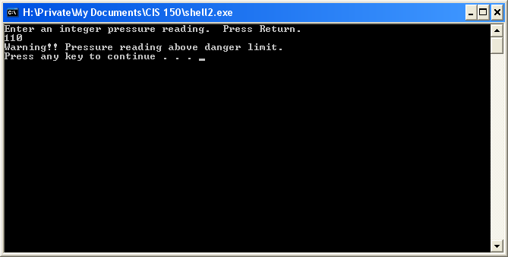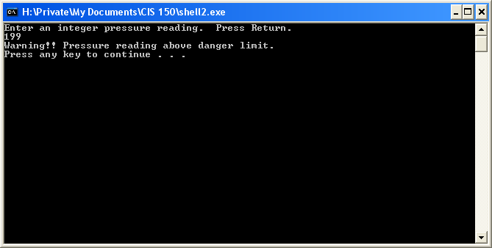

“Warning !! Pressure reading above danger limit.” is printed 2 times.
“Everything seems normal” is printed 3 times.

Exercise 2:

// Program Shell3 calculates a person's percentage of
// calories from fat and prints an appropriate message.

#include <iostream>
#include <string>
using namespace std;

int main ()
{
string foodItem;
int gramsOfFat;
int calories;
float fatCalPercent;

cout << fixed << showpoint;

cout << "Enter the name of a food item."
<< " Press return." << endl;
getline(cin, foodItem);

cout << "Enter the grams of fat; press return." << endl;
cin >> gramsOfFat;

cout << "Enter the number of calories; press return."
<< endl;
cin >> calories;

fatCalPercent = ((gramsOfFat*9.0)/calories)*100;

cout << endl << "Percent from Fat is: "
<< fatCalPercent << "% \n";

system("pause");
return 0;
}

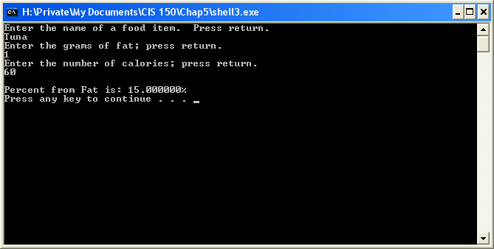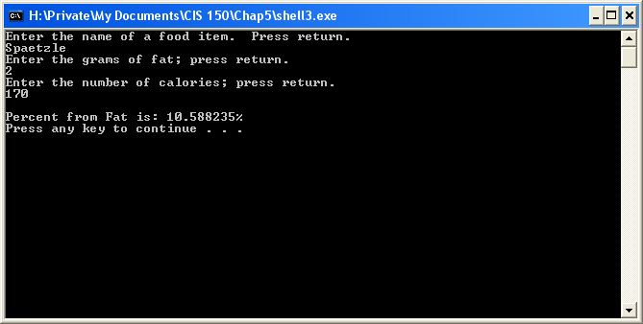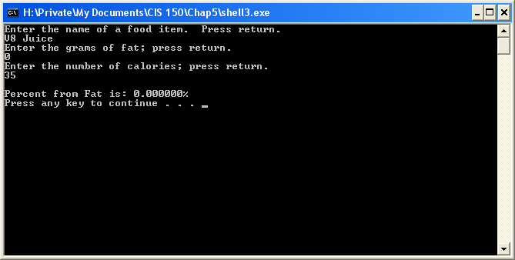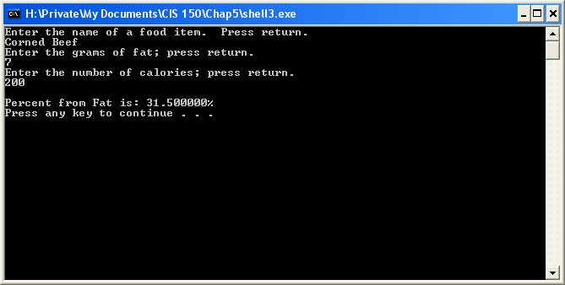

Exercise 3:

// Program Shell3 calculates a person's percentage of
// calories from fat and prints an appropriate message.

#include <iostream>
#include <string>
using namespace std;

int main ()
{
string foodItem;
int gramsOfFat;
int calories;
float fatCalPercent;

cout << fixed << showpoint;

cout << "Enter the name of a food item."
<< " Press return." << endl;
getline(cin, foodItem);

cout << "Enter the grams of fat; press return." << endl;
cin >> gramsOfFat;

cout << "Enter the number of calories; press return."
<< endl;
cin >> calories;

fatCalPercent = ((gramsOfFat*9.0)/calories)*100;

cout << endl << "Percent from Fat is: "
<< fatCalPercent << "% \n" << endl;

if(fatCalPercent > 30.0)
cout << "This item is NOT Heart Healthy!! \n";
else
cout << "This item is Heart Healthy! \n";

system("pause");
return 0;
}
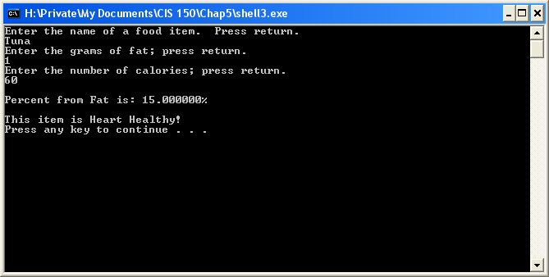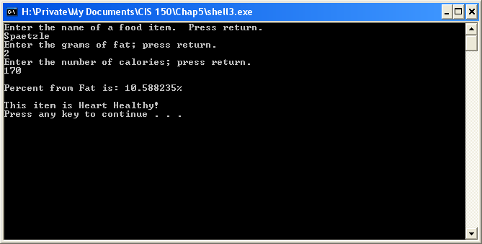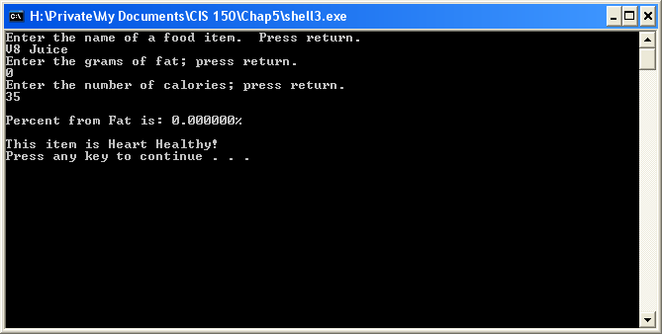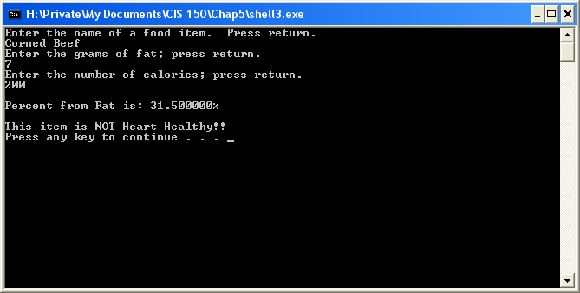

The items that are heart healthy are: Tuna, Spaetzle, and V8 Juice.

Lesson 6-4: Nested Logic:

Exercise 2:

// Program Shell 3 prints appropriate messages based
// on a pressure reading read from a file. Processing
// continues until the plant is evacuated when a pressure
// greater than 100 is read.

#include <iostream>
#include <fstream>
using namespace std;

int main ()

{
int pressure;
ifstream data;

data.open("Shell3.D1");

while(pressure<100)
{

data >> pressure;

if(pressure < 0)
cout << "Error in input.\n";
else if(pressure >=0 && pressure < 50)
cout << "Pressure in the normal range.\n";
else if(pressure >=50 && pressure < 100)
cout << "Pressure on the high side\n";

}
cout << "Evacuate plant!!!!\n";

system("pause");
return 0;
}
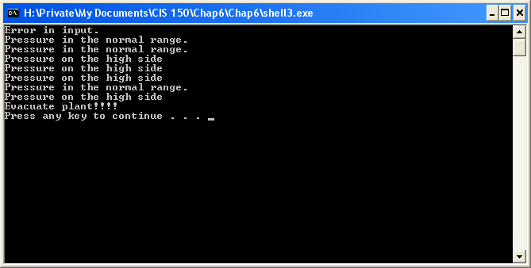

The while loop is an event controlled loop (it will jump out of the loop when it reads an input value greater than 100 or until the data runs out, whichever occurs first).

“Error in input.” was printed 1 time.
“Pressure in the normal range.” was printed 3 times.
“Pressure on the high side.” was printed 4 times.
“Evacuate plant!!!!” was printed 1 time.

Exercise 3:

// Program Shell 3 prints appropriate messages based
// on a pressure reading read from a file. Processing
// continues until the plant is evacuated when a pressure
// greater than 100 is read.

#include <iostream>
#include <fstream>
using namespace std;

int main ()

{
int pressure;
int count;
ifstream data;

count = 0;
data.open("Shell3.D2");

while(pressure<100 && count <60)
{

data >> pressure;

if(pressure < 0)
{
cout << "Error in input.\n";
count++;
}
else if(pressure >=0 && pressure < 50)
{
cout << "Pressure in the normal range.\n";
count++;
}
else if(pressure >=50 && pressure < 100)
{
cout << "Pressure on the high side\n";
count++;
}

}

if (pressure >= 100)
cout <<"Evacuate plant!!!!\n";
else
cout << "Program terminated after " << count << " safe readings.\n";

system("pause");
return 0;
}// Program Shell 3 prints appropriate messages based
// on a pressure reading read from a file. Processing
// continues until the plant is evacuated when a pressure
// greater than 100 is read.

#include <iostream>
#include <fstream>
using namespace std;

int main ()

{
int pressure;
int count;
ifstream data;

count = 0;
data.open("Shell3.D2");

while(pressure<100 && count <60)
{

data >> pressure;

if(pressure < 0)
{
cout << "Error in input.\n";
count++;
}
else if(pressure >=0 && pressure < 50)
{
cout << "Pressure in the normal range.\n";
count++;
}
else if(pressure >=50 && pressure < 100)
{
cout << "Pressure on the high side\n";
count++;
}

}

if (pressure >= 100)
cout <<"Evacuate plant!!!!\n";
else
cout << "Program terminated after " << count << " safe readings.\n";

system("pause");
return 0;
}
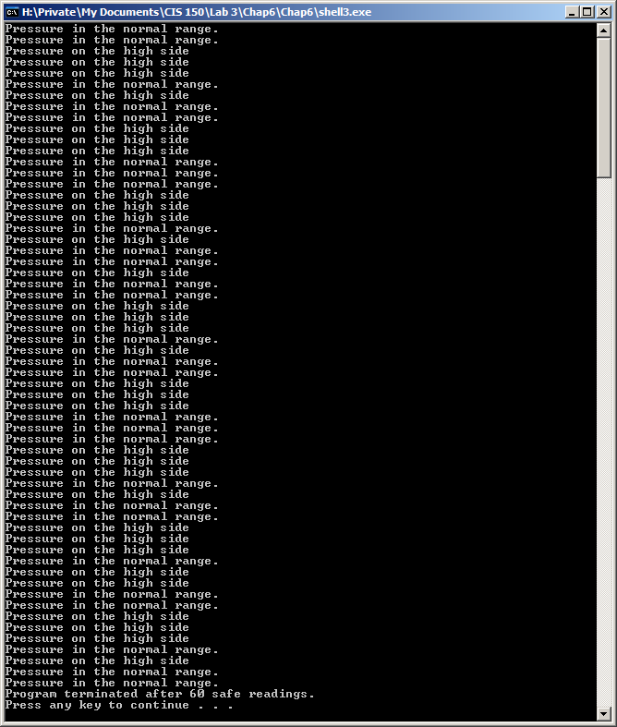

Shell3.D2 ended with 60 safe readings.

// Program Shell 3 prints appropriate messages based
// on a pressure reading read from a file. Processing
// continues until the plant is evacuated when a pressure
// greater than 100 is read.

#include <iostream>
#include <fstream>
using namespace std;

int main ()

{
int pressure;
int count;
ifstream data;

count = 0;
data.open("Shell3.D3");

while(pressure<100 && count <60)
{

data >> pressure;

if(pressure < 0)
{
cout << "Error in input.\n";
count++;
}
else if(pressure >=0 && pressure < 50)
{
cout << "Pressure in the normal range.\n";
count++;
}
else if(pressure >=50 && pressure < 100)
{
cout << "Pressure on the high side\n";
count++;
}

}

if (pressure >= 100)
cout <<"Evacuate plant!!!!\n";
else
cout << "Program terminated after " << count << " safe readings.\n";

system("pause");
return 0;
}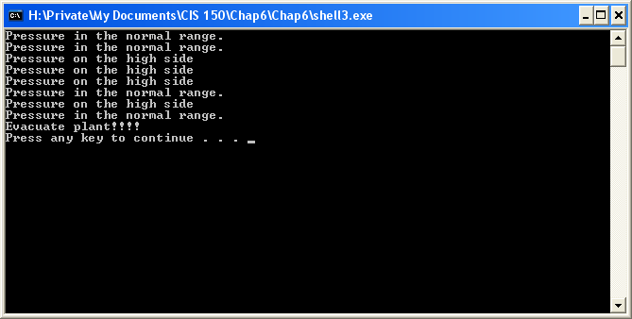

Shell3.D3’s result was that the plant had an unsafe reading and “Evacuate plant!!!” was outputted.

Exercise 4:

For a program to be classified as a count-controlled loop, it must be a function which becomes false when the loop has executed the “expression prescribed number of times”. In short, it uses a counter. An event controlled loop is one whose execution is controlled by the occurrence of an event within the loop itself.

Exercise 5:

